**DN 4.0 Dotnet FSE**

**Name: Sparsh Guha**

**Superset ID:6361106**

**Week 6**

**QUESTION - 1**

**Create a new React Application with the name “myfirstreact”, Run the application to print “welcome to the first session of React” as heading of that page**

**Input:**

**Code:**  
  
1. Install Create React App Tool  
   
npm install -g create-react-app  
  
2. Create a New React Application  
   
npm create-react-app myfirstreact  
  
3. Navigate into the Project Folder  
   
cd myfirstreact  
  
4. Open the Project in Visual Studio Code  
code .  
  
**5.  Edit App.js**  
   
function App() {  
return (  
<div>  
<h1>welcome to the first session of React</h1>  
</div>  
);  
}  
  
export default App;  
  
6. Run the React Application  
   
npm start  
  
7. View in Browser  
Open <http://localhost:3000>

**OUTPUT:**

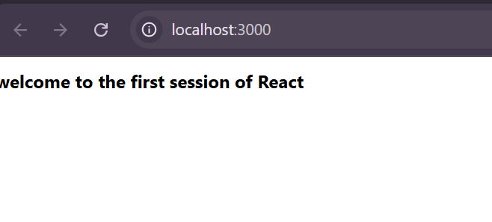

**QUESTION-2**

**Create a react app for Student Management Portal named StudentApp and create a component named Home which will display the Message “Welcome to the Home page of Student Management Portal”. Create another component named About and display the Message “Welcome to the About page of the Student Management Portal”. Create a third component named Contact and display the Message “Welcome to the Contact page of the Student Management Portal”. Call all the three components.**

**INPUT:**

**CODE:**

Step 1: Create a New React App  
npx create-react-app StudentApp  
cd StudentApp  
  
Step 2: Create a Components Folder  
Inside the src folder, create a new folder named Components.  
Step 3: Create Component Files  
**A. Home.js**  
Path: src/Components/Home.js  
  
function Home() {  
return (  
<div>  
<h2>Welcome to the Home page of Student Management Portal</h2>  
</div>  
);  
}  
export default Home;  
  
**B. About.js**  
Path: src/Components/About.js  
  
function About() {  
return (  
<div>  
<h2>Welcome to the About page of the Student Management Portal</h2>  
</div>  
);  
}  
export default About;  
  
**C. Contact.js**  
Path: src/Components/Contact.js  
  
function Contact() {  
return (  
<div>  
<h2>Welcome to the Contact page of the Student Management Portal</h2>  
</div>  
);  
}  
export default Contact;  
  
Step 4: Edit App.js to Render All Components  
**Path: src/App.js**  
  
import Home from './Components/Home';  
import About from './Components/About';  
import Contact from './Components/Contact';  
  
function App() {  
return (  
<div>  
<Home />  
<About />  
<Contact />  
</div>);}  
export default App;  
Step 5: Run the Application  
npm start  
Open your browser and go to <http://localhost:3000>

**OUPUT:**

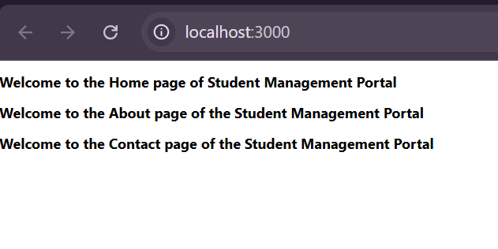

**QUESTION-3**

**Create a react app for Student Management Portal named scorecalculatorapp and create a function component named “CalculateScore” which will accept Name, School, Total and goal in order to calculate the average score of a student and display the same**.

**INPUT AND CODE:**

1. Create a New React App in a Separate Directory  
   npx create-react-app scorecalculatorapp  
   cd scorecalculatorapp  
     
   2. Create Components Directory and File  
   In src, create a folder named Components.  
   Inside src/Components, create a file named CalculateScore.js.  
   **src/Components/CalculateScore.js:**  
   import React, { useState } from 'react';  
   import '../Stylesheets/mystyle.css';  
   function CalculateScore() {  
   const [name, setName] = useState('');  
   const [school, setSchool] = useState('');  
   const [total, setTotal] = useState('');  
   const [goal, setGoal] = useState('');  
   const [average, setAverage] = useState(null);  
   const handleSubmit = (e) => {  
   e.preventDefault();  
   if (total && goal) {  
   setAverage(((parseFloat(total) + parseFloat(goal)) / 2).toFixed(2));  
   }  
   };  
   return (  
   <div className="score-container">  
   <h2>Student Score Calculator</h2>  
   <form onSubmit={handleSubmit}>  
   <input type="text" placeholder="Name" value={name} onChange={e => setName(e.target.value)} required />  
   <input type="text" placeholder="School" value={school} onChange={e => setSchool(e.target.value)} required />  
   <input type="number" placeholder="Total" value={total} onChange={e => setTotal(e.target.value)} required />  
   <input type="number" placeholder="Goal" value={goal} onChange={e => setGoal(e.target.value)} required />  
   <button type="submit">Calculate Average</button>  
   </form>  
   {average && (  
   <div className="result">  
   <p>{name} from {school} has an average score of {average}.</p>  
   </div>  
   )}  
   </div>  
   );}  
   export default CalculateScore;  
     
   3. Create Stylesheets Directory and CSS File  
   In src, create a folder named Stylesheets.  
   Inside src/Stylesheets, create a file named mystyle.css.  
   **src/Stylesheets/mystyle.css:**  
     
   .score-container {  
   max-width: 400px;  
   margin: 40px auto;  
   padding: 20px;  
   border: 2px solid #0074d9;  
   border-radius: 8px;  
   background: #f0f8ff;  
   font-family: Arial, sans-serif;  
   }  
   .score-container h2 {  
   color: #0074d9;  
   }  
   .score-container input {  
   display: block;  
   width: 95%;  
   margin: 10px 0;  
   padding: 8px;  
   border-radius: 4px;  
   border: 1px solid #ccc;  
   }  
   .score-container button {  
   background: #0074d9;  
   color: #fff;  
   border: none;  
   padding: 10px 16px;  
   border-radius: 4px;  
   cursor: pointer;  
   }  
   .score-container .result {  
   margin-top: 20px;  
   font-weight: bold;  
   color: #333;  
   }  
     
   4. Edit App.js to Use the Component  
   **src/App.js:**  
   import CalculateScore from './Components/CalculateScore';  
   function App() {  
   return (  
   <div>  
   <CalculateScore />  
   </div>  
   );  
   }  
   export default App;  
   5. Run the Application  
   npm start  
   Open your browser and go to <http://localhost:3000>

**OUTPUT:**

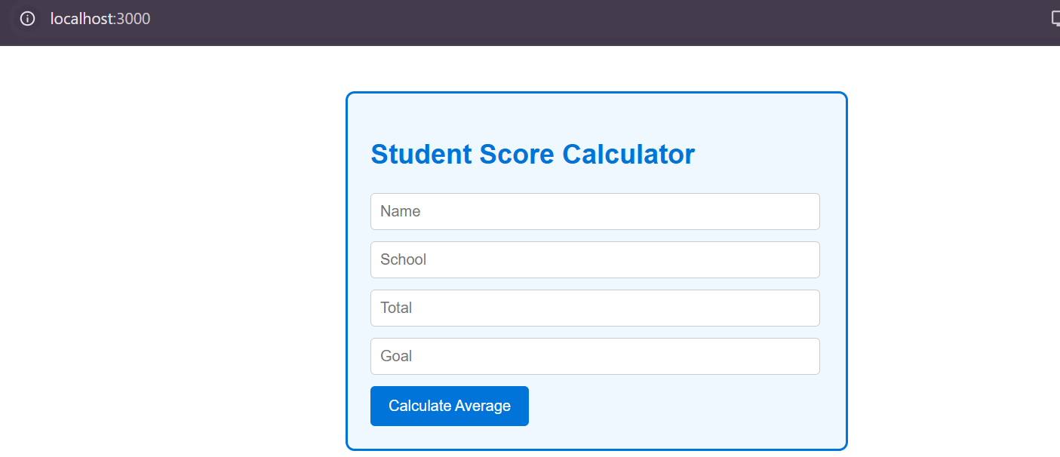

**QUESTION-4**

**Create a new react application using *create-react-app* tool with the name as “blogapp”**

**CODE AND INPUT:**

Step 1: Create a New React App  
npx create-react-app blogapp  
cd blogapp  
  
Step 2: Create the Post Component  
**File: src/Post.js**  
import React from 'react';  
function Post({ title, body }) {  
return (  
<div>  
<h2>{title}</h2>  
<p>{body}</p>  
</div>  
);  
}  
  
export default Post;  
Step 3: Create the Posts Class Component  
**File: src/Posts.js**  
  
import React, { Component } from 'react';  
import Post from './Post';  
class Posts extends Component {  
constructor(props) {  
super(props);  
this.state = {  
posts: [],  
hasError: false,  
errorMessage: ''  
};  
}  
loadPosts() {  
fetch('https://jsonplaceholder.typicode.com/posts')  
.then(res => res.json())  
.then(data => this.setState({ posts: data }))  
.catch(error => {  
this.setState({ hasError: true, errorMessage: error.message });  
});  
}  
componentDidMount() {  
this.loadPosts();  
}  
componentDidCatch(error, info) {  
this.setState({ hasError: true, errorMessage: error.toString() });  
alert('An error occurred: ' + error.toString());  
}  
render() {  
if (this.state.hasError) {  
return <div>Error: {this.state.errorMessage}</div>;  
}  
return (  
<div>  
<h1>Blog Posts</h1>  
{this.state.posts.map(post => (  
<Post key={post.id} title={post.title} body={post.body} />  
))}  
</div>  
);}}  
export default Posts;  
Step 4: Use the Posts Component in App.js  
**File: src/App.js**  
import Posts from './Posts';  
function App() {  
return (  
<div>  
<Posts />  
</div>  
);  
}  
export default App;  
  
Step 5: Run the Application  
npm start  
  
Open <http://localhost:3000>

**OUTPUT:**

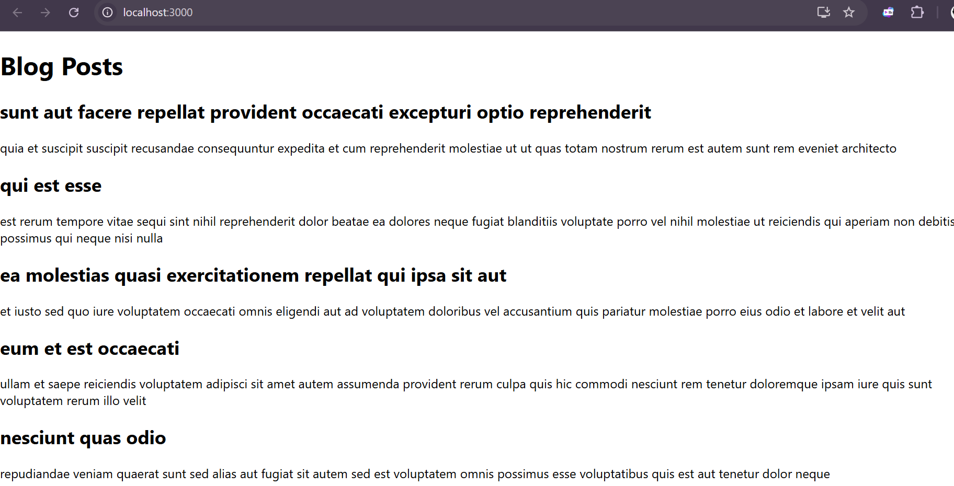

**QUESTION-5**

**My Academy team at Cognizant want to create a dashboard containing the details of ongoing and completed cohorts. A react application is created which displays the detail of the cohorts using react component. You are assigned the task of styling these react components.**

**Download and build the attached react application**.

1. Unzip and Set Up the Provided React App  
   Unzip the Cohort Tracker zip file into a new folder.  
   Open a terminal/command prompt and navigate to the unzipped folder (the one with package.json).  
   Restore node packages:  
   npm install  
   2. Open in Visual Studio Code  
   Open the folder in VS Code:  
   code .  
   3. Create a CSS Module for Styling  
   **File: src/CohortDetails.module.css**  
    .box {  
   width: 300px;  
   display: inline-block;  
   margin: 10px;  
   padding: 10px 20px;  
   border: 1px solid black;  
   border-radius: 10px;  
   }  
   dt {  
   font-weight: 500;  
   }  
   4. Update the CohortDetails Component  
   **File: src/CohortDetails.js**  
   import styles from './CohortDetails.module.css';  
   function CohortDetails(props) {  
   const h3Style = {  
   color: props.cohort.currentStatus === "ongoing" ? "green" : "blue"  
   };  
   return (  
   <div className={styles.box}>  
   <h3 style={h3Style}>  
   {props.cohort.cohortCode} -  
   <span>{props.cohort.technology}</span>  
   </h3>  
   <dl>  
   <dt>Started On</dt>  
   <dd>{props.cohort.startDate}</dd>  
   <dt>Current Status</dt>  
   <dd>{props.cohort.currentStatus}</dd>  
   <dt>Coach</dt>  
   <dd>{props.cohort.coachName}</dd>  
   <dt>Trainer</dt>  
   <dd>{props.cohort.trainerName}</dd>  
   </dl>  
   </div>  
   );  
   }  
   export default CohortDetails;  
   5. Run the Application  
   npm start  
   Open your browser to <http://localhost:3000>

**OUTPUT:**

